KINGTON ST MICHAEL 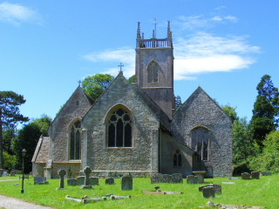
BRAMBLES, BEGINNERS AND BOB DOUBLES
We were ‘found’ by a band of ringers from St Andrews in Chippenham. We had volunteered to start clearing some of the brambles at the back of the Kington St Michael churchyard. We had no idea that the church had not had a ringing band for over 25 years and were duly invited to join a new practice night on Monday.
On that Monday evening we were joined by two other experienced ringers who live in the village, Ian and Sheila Wills.
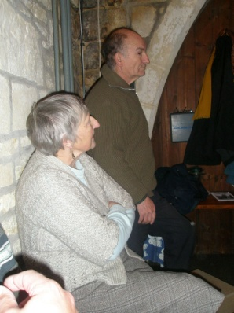
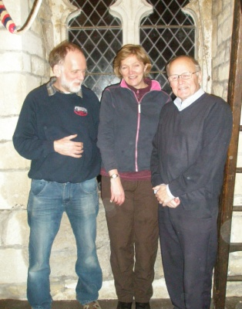
We were and still are, expertly taught by Dick Gray, Joanna Wheatland, Rodney Brown, and
Caroline Emerson.

We have also benefitted from all the extra helpers from the Branch who regularly turn up to assist. We started with five new learners, sadly during the year has dwindled to two.
The first thing we learnt was that ‘our’ bells are anti-clockwise. This meant nothing of course until our first venture to Langley Burrell, when we realised the full implication of this and began to struggle once again on simple rounds!
The majority of villagers are delighted to hear the bells; our initial practice time was changed to accommodate a family with school age children whose 8pm bedtime meant the bells kept them awake. In the early days we also rang with the clapper muffled, until we progressed to the stage of rounds.
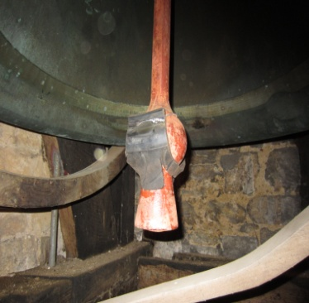
We had a clear and ambitious lesson plan displayed on the noticeboard in the tower and progressed steadily through it, some faster than others.
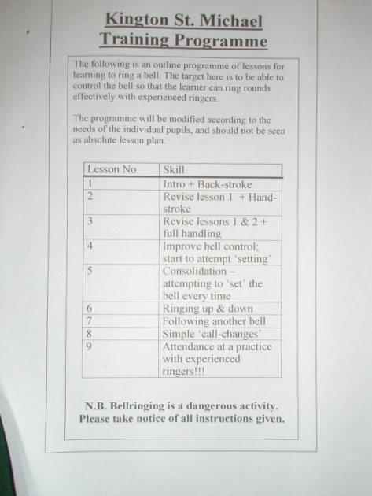
In one year of 1hour a week practice we have progressed from Rounds, to Call Changes and then Plain Hunt. Our current challenge is Bob Doubles, rope sight is getting better, the cycle of work becoming clearer, and passing the treble gradually having more meaning. We have touched on Grandsire Doubles and Adam has successfully completed his first Quarter Peal.
The help advice and support we have had is invaluable, everyone has a different way of explaining things, what is sometimes a hazy understanding suddenly becomes clear.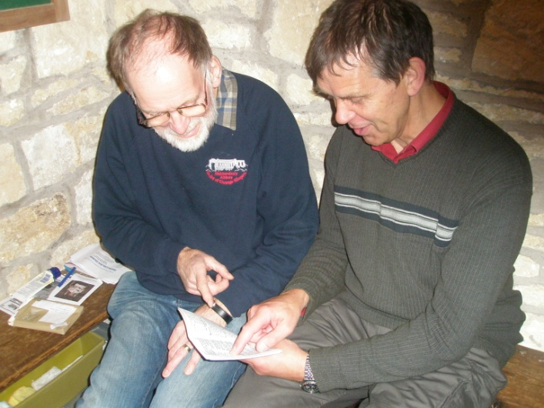
Ringing now occurs on the first Sunday in every month for the Service, and we were personally thanked by the Vicar, the congregation are delighted.
We attended the Branch Training Days which we thoroughly enjoyed and learnt a huge amount from the very experienced ringers there, and enjoyed the warm welcome from the other members. Ringing on 12 bells at Shrivenham was very exciting.
Ian Wills ensures the tower is maintained to a high standard, having attended courses in tower maintenance.
We were delighted and surprised at the end of our year of ringing to receive the ‘Most Improved Tower Award’, which is proudly displayed in our Tower.
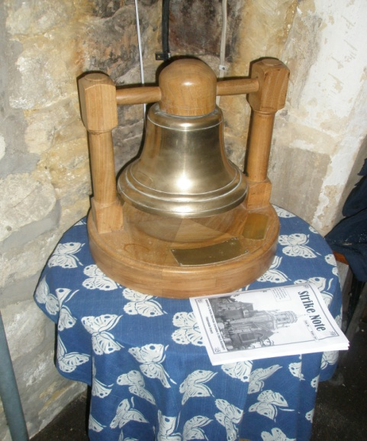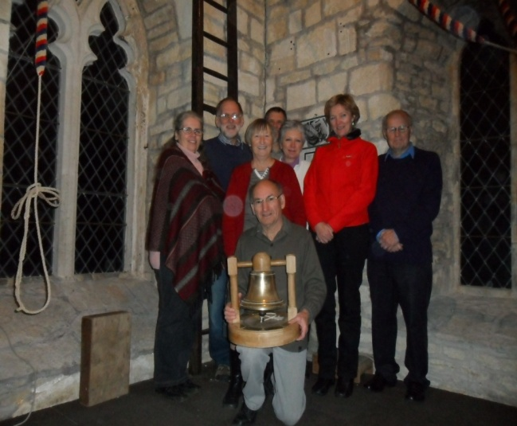
We have started a page on the Village website, http://www.kingtonstmichael.com/Contents/Text/Index.asp?SiteId=126&SiteExtra=2875842&TopNavId=299&NavSideId=17758 , and have put flyers around the village to find more beginners. We have now started training again with four new recruits.
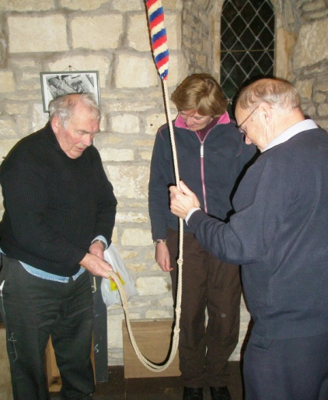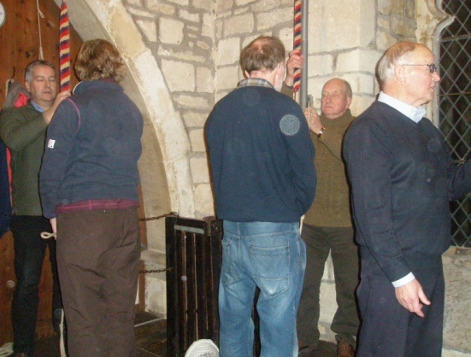
Where did we find them…they were volunteers clearing the churchyard of its final few brambles, and revealing ancient tombstones, as we have awakened the lost bells of Kington St Michael.
Adam and Diane Allen
Ian and Sheila Wills
Jan 2014

